Costiug Mihai, gr 922/1

College Admission

Project Statement:

We want to develop a program for handling the candidates of the Computer Science and Math Faculty. The application lets you add a new candidate (CNP, Name, Address, BAC average, math or computer science high school average; the final grade for the admission is the mean average between the last two, and the list of options), edit fields of already entered candidates, generate the results, list all admitted candidates for each section, list all rejected candidates. A candidate can choose any of the sections offered by the faculty. Number, name of sections and number of available positions are configurable (not constant in the program).

Specifications:

Preconditions:
Candidates are read from the file “candidates.txt”. Each candidate will be on its own row, fields being separated by “;”. On the first field we have the CNP, on the second the name, on the third the address, on the forth the math or computer science high school average, on the fifth the options. If the format is not respected, the student is not read. The CNP should have 13 digits, the average should be of type double and the options are strings separated by “,”. The options must exist in the “sections.txt”.
The sections and number of positions available are read from file “sections.txt”. Each section will be on its own row, fields being separated by “;”. On the first field we have the name, on the second the number of positions available. The second field should be a positive integer. If the format is not respected, the section is not read.

Postconditions:
The failed candidates are stored in a file named “failed.txt” in the format “CNP;name”.
The admitted candidates are stored in a file named “admitted.txt” in the format “CNP;name;sectionName”.

Use case diagram:

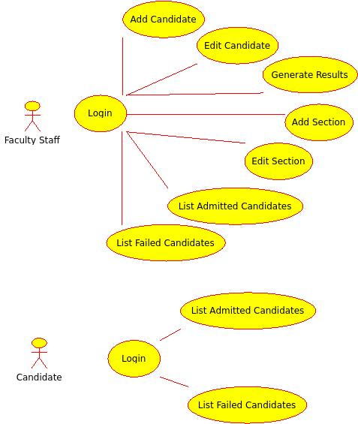

Class diagram:

